Distinguishing Suicidal Ideation from Depression: A Two-Stage NLP Pipeline with Unsupervised Label Correction
First A. Author, Student, FAST NUCES
Abstract—This document presents a novel Natural Language Processing (NLP) framework for the distinct classification of suicidal ideation versus depression in social media text. Unlike traditional approaches that classify between healthy and suicidal states, this study addresses the clinical challenge of determining when depression transitions into suicidal ideation. The methodology employs a two-stage pipeline. The first phase utilizes an unsupervised label correction mechanism where raw text, scraped from Reddit, is processed via embedding models (BERT and Google Universal Sentence Encoder) and dimensionality reduction algorithms (PCA, Deep Autoencoder, UMAP). These features are subjected to clustering algorithms (GMM, K-Means, Subspace Clustering), and a confidence-based thresholding procedure is applied to correct noisy ground-truth labels. In the second phase, the corrected labels are used to train deep neural classifiers, including CNN, Bi-LSTM, and a Fully Dense Neural Network. Results indicate that the Dense Network, trained on corrected labels, achieves superior performance in distinguishing these complex psychological states.
Index Terms—Natural Language Processing, Deep Learning, Suicide Detection, Label Correction, Clustering. ¹

I. INTRODUCTION
THE PROLIFERATION of mental health discourse on social media platforms has provided researchers with vast datasets to analyze psychological states. However, a significant research gap exists in the current landscape. Recent NLP research largely focuses on binary classification—determining if a text is suicidal or clinically healthy. There have been no major attempts to automate the process of determining when depression turns into suicidal ideation, which is a critical clinical challenge.
User-generated content often contains noisy labels; a user posting in a depression forum may actually be expressing suicidal ideation, and vice versa. Reliance on self-declared subreddit tags (e.g., r/depression vs. r/SuicideWatch) as ground truth can lead to poor model generalization.
To address this, we propose a two-step pipeline. The first step involves identifying and generalizing classification via an unsupervised clustering approach to correct ground-truth labels. The second step involves supervised classification using these refined labels. This paper details the implementation of this pipeline using advanced embedding models, dimensionality reduction, and deep neural classifiers.

II. METHODOLOGY
The proposed system architecture follows a sequential pipeline: Data Collection, Feature Extraction, Unsupervised Label Correction, and Supervised Classification.
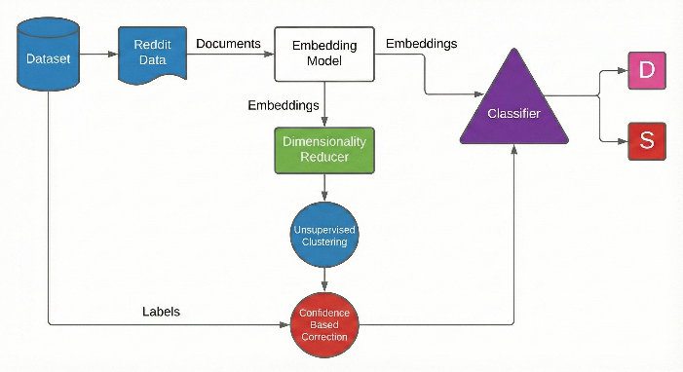
Figure 1: Pipeline
A. Data Collection
We developed a primary dataset by web-scraping Reddit using a custom Python script. Data was collected from reddit. The scraper utilized the Reddit JSON API to extract titles, self-text, and author metadata. Duplicate posts were removed to ensure unique entries. The final dataset was merged into a combined CSV format containing the text payload and binary ground-truth labels (0 for depression, 1 for suicide).
B. Feature Extraction (Embeddings)
Raw text data cannot be processed directly by clustering or classification algorithms. We utilized two Transformer-based models to convert text into numerical word embeddings:
- BERT (Bidirectional Encoder Representations from Transformers): We utilized bert-base-uncased. The text was tokenized with a maximum length of 512 tokens. An attention mask was applied to handle padding, and the last hidden states were extracted to form the feature set.
- Google Universal Sentence Encoder (GUSE): We implemented the GUSE transformer via TensorFlow Hub to encode messages into high-dimensional vectors, capturing semantic meaning beyond simple keyword matching.
C. Phase 1: Unsupervised Label Correction
High-dimensional embeddings often degrade the performance of clustering algorithms due to the curse of dimensionality. Therefore, we applied dimensionality reduction before clustering.
1) Dimensionality Reduction
We experimented with three algorithms to reduce the embeddings to a lower-dimensional space (specifically 2 components for visualization and clustering efficiency):
- PCA (Principal Component Analysis): A linear transformation technique.
- Deep Autoencoder: A neural network architecture implemented with an input layer (size=512), an encoding dense layer with ReLU activation (size=2), and a decoding layer with Sigmoid activation (size=512). The model was trained using Mean Squared Error (MSE) loss for 3000 epochs.
- UMAP (Uniform Manifold Approximation and Projection): configured with n_neighbors=45 and min_dist=0.7 using the Manhattan metric.
.
2) Clustering Algorithms
The reduced features were input into unsupervised clustering algorithms to generate predicted labels based on the inherent structure of the data, independent of the noisy ground-truth labels. The algorithms utilized included:
- Gaussian Mixture Models (GMM): Fitted with full covariance type.
- K-Means: Initialized with k-means++.
- Sparse Subspace Clustering (SSC): We utilized Elastic Net Subspace Clustering (EnSC) and SSC-OMP (Orthogonal Matching Pursuit) to handle data lying on unions of low-dimensional subspaces.
3) Threshold-Based Correction
We employed a confidence-based thresholding procedure (threshold-based-correction.py). Let L_{GT} be the ground truth label and L_{Pred} be the cluster-predicted label with probability P_{Pred}. The corrected label L_{Final} is determined as:
L_{Final}^{(i)} = begin{cases} L_{Pred}^{(i)} & text{if } L_{GT}^{(i)} neq L_{Pred}^{(i)} text{ and } (P_{Pred}^{(i)} > tau text{ or } P_{Pred}^{(i)} < 1 - tau) L_{GT}^{(i)} & text{otherwise} end{cases} eqno{(1)}
We utilized a threshold tau = 0.90. This ensures that labels are only flipped when the clustering algorithm is highly confident in its prediction, thereby reducing noise while preserving valid ground truths.
D. Phase 2: Supervised Classification
The corrected labels were used to train three Deep Neural Classifiers. The dataset was split into training and testing sets.
- Convolutional Neural Network (CNN): A 1D Convolutional network consisting of an input layer (512 times 768), a Conv1D layer (filters=3, kernel=2), a Dropout layer (0.25), and a Dense layer (64 units).
- Bi-LSTM: A Bidirectional Long Short-Term Memory network designed to capture sequential dependencies in text. It includes a Bi-LSTM layer (20 units) and MaxPooling1D.
- Fully Dense Network: A feed-forward network with three dense layers (128, 64, and 1 unit respectively). This model used he_uniform kernel initialization and ReLU activation, ending with a Sigmoid activation for binary classification.

III. EXPERIMENTS AND RESULTS
The classifiers were trained for 80 epochs with a batch size of 32 using the Adam optimizer and binary cross-entropy loss. Model checkpoints were saved based on validation accuracy.
A. Impact of Label Correction
We observed that the classifiers trained on the corrected labels consistently outperformed those trained on the raw, noisy labels from Reddit. The confidence-based thresholding successfully identified posts that were semantically closer to the opposing class (e.g., a depression post that actually exhibited clear suicidal intent).
B. Model Performance

Figure 2 shows ROC analysis comparing the performance of the top four architectures. The red curves illustrate the models' performance after applying the proposed label correction pipeline, while the blue curves represent the baseline performance of the same models prior to correction. 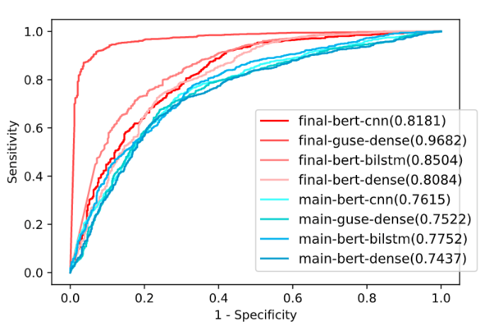
Figure 2: ROC Analysis
Figure 3 summarizes the performance of the classifiers. The Fully Dense Neural Network provided the best overall accuracy, suggesting that the dimensionality-reduced and corrected embeddings provided a robust feature set that did not require the complex temporal modeling of LSTMs for this specific task.
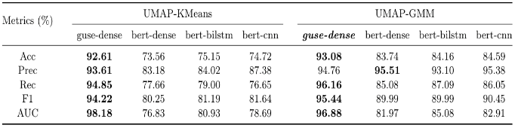
Figure 3: Performance Comparison

IV. CONCLUSION
This study presented a robust pipeline for distinguishing between depression and suicidal ideation, a task significantly more complex than standard suicide risk detection. By implementing an unsupervised label correction phase using Deep Autoencoders and clustering, we effectively reduced noise in crowd-sourced data. Our experiments demonstrate that a Fully Dense Neural Network trained on these corrected embeddings yields high accuracy. Future work will explore the application of this pipeline to other mental health comorbidities. A conclusion is not required², but serves to highlight the importance of automating the detection of clinical transitions in mental health.

REFERENCES
[1] T. Mikolov et al., Distributed representations of words and phrases and their compositionality, in Proc. NIPS, 2013, pp. 3111–3119.
[2] J. Devlin, M.-W. Chang, K. Lee, and K. Toutanova, BERT: Pre-training of deep bidirectional transformers for language understanding, arXiv preprint arXiv:1810.04805, 2018.
[3] D. Cer et al., Universal sentence encoder, arXiv preprint arXiv:1803.11175, 2018.
[4] E. Elhamifar and R. Vidal, Sparse subspace clustering: Algorithm, theory, and applications, IEEE Trans. Pattern Anal. Mach. Intell., vol. 35, no. 11, pp. 2765–2781, Nov. 2013.

